**SRS Diagrams**



Session: 2022 – 2026

**Submitted by:**

Mian Muhammad Ashhad

2022-CS-114

**Submitted to:**

Miss Mariyam

Department of Computer Science

**University of Engineering and Technology**

**Lahore Pakistan**

**Decision Table:**

|  |  |  |  |  |
| --- | --- | --- | --- | --- |
| **Condition** | **Order Valid** | **Payment Processed** | **Delivery Available** | **Action Taken** |
| Valid order, payment successful, delivery available | Yes | Yes | Yes | Confirm order, notify restaurant, assign delivery person |
| Valid order, payment successful, delivery not available | Yes | Yes | No | Notify user: Delivery unavailable, provide pickup option |
| Valid order, payment unsuccessful | Yes | No | N/A | Notify user: Payment failed, request new payment method |
| Invalid order, payment not processed | No | No | N/A | Notify user: Invalid order, prompt for correction |
| Valid order, payment successful, restaurant closed | Yes | Yes | N/A | Notify user: Restaurant closed, suggest alternatives |
| Valid order, payment successful, out of delivery area | Yes | Yes | No | Notify user: Out of delivery area, offer pickup option |
| Valid order, payment successful, delivery delayed | Yes | Yes | Yes (delayed) | Notify user: Delivery delayed, provide estimated time |
| Valid order, payment successful, item unavailable | Yes | Yes | N/A | Notify user: Item unavailable, suggest alternatives |
| Payment successful, user cancels order | Yes | Yes | N/A | Cancel order, process refund, notify restaurant |
| Order placed but payment not completed (pending) | Yes | Pending | N/A | Notify user: Payment pending, hold order temporarily |

**Class Diagram:**

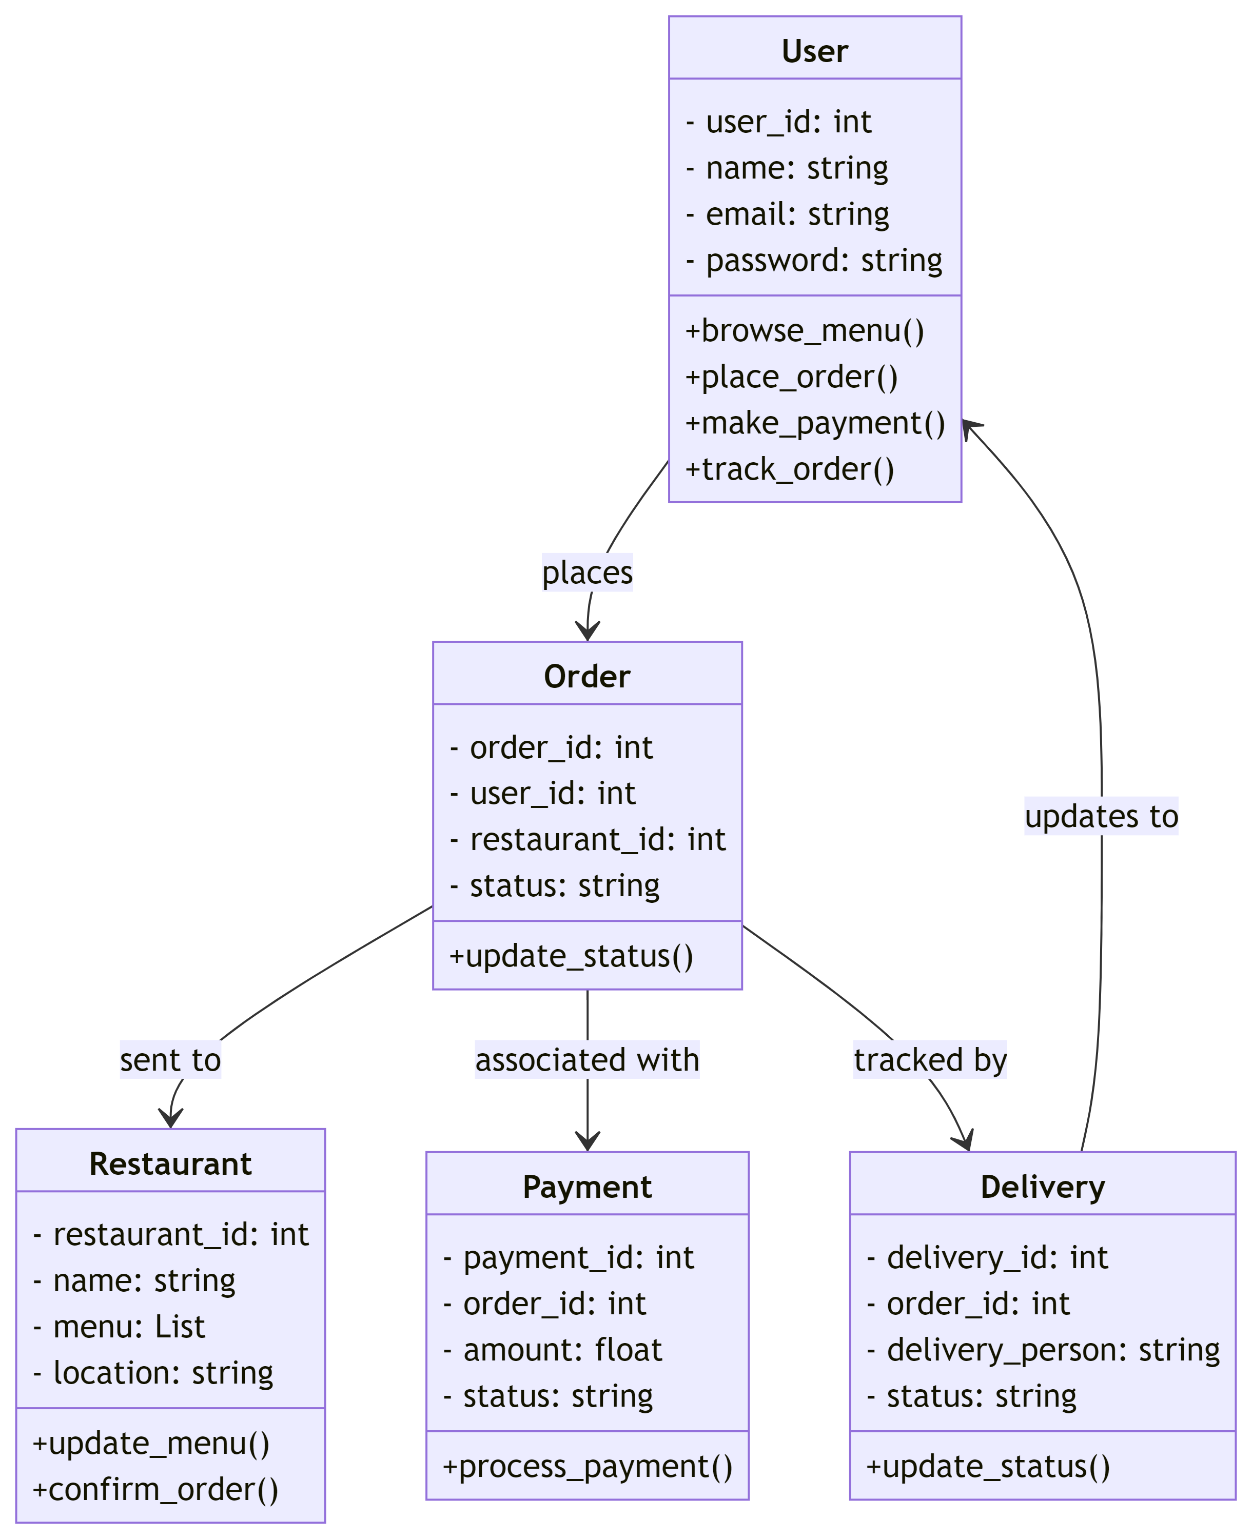

Use Case Diagram:

